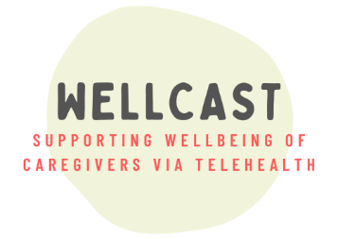
Now Hiring Rare Disorder Caregivers to be Peer Coaches!
The research team in the Kelleher Lab at Purdue University is hiring caregivers of individuals with neurogenetic conditions to join our research team! Successful candidates will be compensated to serve as peer coaches within Project WellCAST, a NIH-funded clinical trial that aims to support caregiver well-being through supportive therapy, resources, and family friendly treatment.
Project WellCAST (PI: Dr. Bridgette Kelleher; she/her) will support up to 1,000 caregivers of children with a variety of neurogenetic syndromes associated with intellectual disability, including (but not limited to) Angelman syndrome, Down syndrome, Dup15q syndrome, fragile X syndrome, Prader Willi syndrome, and Williams syndromes. Some of these participants will be assigned a peer coach who will support them throughout their Project WellCAST journey. That’s where YOU come in!
Peer coaches will learn how to deliver a “Participation Enhancement Intervention (PEI) program.” This evidence-based coaching program aims to help study participants meet their therapeutic goals. Each peer coach will support up to 8 participants at a time through regular check-in meetings. Coaches are also core members of our WellCAST leadership team and will be invited to provide meaningful input on all aspects of the project. Previous experience in research or academic settings is not required; we value your lived experience!
Your responsibilities as a peer coach:
- Complete virtual training to become a peer coach. Trainings will occur across several weeks and include a three-hour workshop, practice sessions, and biweekly check-in meetings throughout the project.
- Complete the peer coaching program with up to 8 clients at a time. The protocol includes four meetings per client, spread out across several weeks.
- Complete brief forms about your client’s experiences, as well as your experiences as a coach. These forms must be completed in a timely manner.
- Apply your lived experience as a rare disorder caregiver to improve the project, including by sharing your input with the broader Project WellCAST leadership community during “think tank” meetings.
- Create a supportive and inclusive space for families with diverse experiences and identities.
- Uphold ethical rules of the research study, including by maintaining participants’ confidentiality.
- Commit to a regular schedule of meetings with coaching clients; meetings must be held in a private space free from distractions.
All activities are completed virtually and begin July 2023.
Additional Information: Coaches will be paid $20/hour for training and coaching. It is estimated that coaches will complete between 200 and 250 hours of activities across the project. Candidates must over 18 years of age, be eligible to work in the United States, live in the US, and be willing to complete a I-9 form. The I-9 form requires a social security number and is required for tax purposes. Peer coaches may not be current Project WellCAST participants and should not apply if they would like to participate in the study treatments; however, caregivers who have participated in past Kelleher Lab WellCAST projects are welcome to apply.
To apply: Candidates should submit the attached application to Veronika (she/her) at Wellcast@purdue.edu.
Purdue University is an EEO/AA employer fully committed to achieving a diverse workforce. All individuals, including minorities, women, individuals with disabilities, and protected veterans are encouraged to apply.
Project WellCAST: Peer Coaching Application
Applicant Information:
Full Name:
Pronouns (optional):
Zip Code:
Are you 18 years or older and eligible to work in the United States?

Application Questions:
Please answer the following three questions. You may send your response as a written document (no more than a page total, please). Alternatively, you may video or audiotape your responses.

- Are you a caregiver and/or parent of a child (including a current adult) diagnosed with a rare neurogenetic condition? If so, please describe your caregiving experience, including how long you have been a rare disorder caregiver. Where would you describe yourself in your caregiving journey?

- Please describe your experiences participating in mentorship or support (formally or informally) to other rare disorder parents and/or caregivers. Examples may include engagement with foundations, participating in support groups or school events, professional experiences, or building informal relationships with families.
- Project WellCAST is an inclusive space for caregivers with a variety of backgrounds, identities, experiences, and values. What does diversity and inclusion mean to you? Can you provide an example of how you have helped people with different identities or backgrounds feel included and respected?

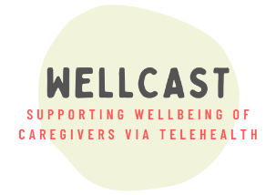
What happens next? Please send your application to Veronika Vozka (she/her), Project WellCAST coordinator, at wellcast@purdue.edu . Applicants will be notified whether they are invited to interview by the end of June.

