F31 Planning Manual for Psychology Graduate Students
Part I: Training and Mentorship
Version 1.2 | Last updated 9/13/18 | Dr. Bridgette Tonnsen, Purdue University
This manual is designed to support graduate students in initial stages of pursuing NIH F31 fellowships. These materials are free for use, but please seek permission from Dr. Tonnsen (btonnsen@purdue.edu) before disseminating to others.
SHOULD I GO FOR IT?
Per NIH, the goal of a Ruth L. Kirschstein Predoctoral Individual National Research Service Award (F31) is “to provide predoctoral individuals with supervised research training in specified health and health-related areas leading toward the research doctoral degree (e.g., PhD).” Obtaining a F31 grant can be a career-shifting experience, as the training grant can provide specialized training, research opportunities, and protected research time. The mechanism provides a chance for students to establish a “dream team” of mentors who have committed up front to supporting the student in pursuing a specific project, which can in turn lead to high-impact papers, pilot data for future grants, and a student-owned dataset that can be used during their early career. The process of writing a F31 grant is also – in and of itself – a professional development experience. You are able to learn first-hand about the grant writing experience, ranging from the scientific strategy involved in designing a research plan to the technical details involved with budgetary planning and submission. When deciding whether to apply, the following questions may be helpful:
- Am I eligible? Some students may not be eligible for F31s, particularly if they are not a U.S. citizen or permanent resident. Do not apply if you are not eligible.

- Is my NIH institute accepting applications? Not all NIH institutes accept F31 fellowships. Check the current funding opportunity announcement (FOA) for a list of participating organizations.

- Am I ready? It is generally in students’ best interest to submit F31s when they have a demonstrated track record of “promise” (e.g. a few papers under review, internal small grants, conference presentation). Students need not have “all-star” records to submit, however there should be some evidence of an accelerating trajectory.

- Is it too late? Students should not submit F31 fellowships if they are so late in their training that reviewers will question their need for additional mentored training. For example, F31s are rarely awarded to students in their final years of graduate study.

- Do I have time? It takes a whoppingly surprising amount of time to craft a high-quality F31 proposal. Funded proposals must be well thought-through, highly integrative, and free from technical errors. You should allow time for several rounds of revisions. Do not waste time throwing together a half-hearted proposal.

- Am I linked to a NIH-funded project, or can I make the case that my mentor has access to the materials I need to be successful? Most F31s are “linked” to a funded NIH project, as the training allowance is not sufficient to fund a standalone project ($3K-$4K per year). Many times, the primary mentor is actively funded by NIH or is directly involved in a NIH-funded project. Linking to a NIH-funded study helps reviewers know that your parent protocol is already “peer reviewed” by NIH. However in some cases, students may make the case that their mentor can support their training plan without substantial funding. For example, students may access a collaborator’s dataset, generate simulated data, or leverage public access resources.

- Is my institution supportive? Will your institution (and mentor) give you the space, time, and resources you need to complete your training plan? Will your department head write you a strong letter of support?

- Do I have time for a resubmission? Few F31s (or any grant, really) are funded on the first go-round. You will want to ensure that your F31 resubmission timeline also aligns with your graduate training. See later sections for details.

- Does my research interest align with NIH’s mission? NIH is interested in public health. If your research interests do not relate to health, you should not apply for a NIH fellowship. Instead, look other government-funded agencies (e.g. NSF) or private foundations. However, do not shy away from a NIH fellowship if your interests could have a public health impact that you have not yet explored. Basic psychological methods and constructs may still be relevant for health – and it is possible that the mentored training afforded by a F31 could help you bridge the gap.

- Are mentorship and training opportunities available? NIH wants to see that you are using a F31 fellowship to obtain skills that you would otherwise not obtain in your traditional course of study. The award should accelerate your trajectory. NIH does not want to fund your dissertation, or your advisor’s pet project, or a study you can accomplish with your current skillset. The F31 protects your time for training activities, gives you a little money for your training, and solidifies a team of mentors who have pre-agreed to support your training. If you do not want to learn anything new, do not apply for a F31. If you do not have a mentor willing to supervise you, do not apply for a F31. If you do not have access to mentors who have strong track records of success (e.g. highly published, NIH-funded – although these qualities can be distributed across mentors), do not apply for a F31.

- Do you actually want a research career? Perhaps it goes without saying, but F31s are designed to accelerate trajectories of research-focused early career scientists. Your work may have a clinical bent, but NIH does not want to fund folks who will leave the research world upon graduation. The time you sank into writing and completing your F31 will also not be very helpful in a non-research career. So, do not view the F31 as a “badge of honor” that should be pursued no matter what – do it if it makes sense for you.

WHAT RESOURCES ARE AVAILABLE TO HELP ME?
Before you start diving into a research plan, it is important to be well informed about the structure and scope of a successful F31 grant. A good checklist for pre-writing review materials may include:

- The current FOA for your grant mechanism (e.g. the F31) – be sure you are looking at most recent version

- The current instructions for fellowship grants, known as the SF-424 D series (https://grants.nih.gov/grants/how-to-apply-application-guide/forms-d/fellowship-forms-d.pdf)

- 1-2 previous successful applications. These can be obtained from folks who have received F31s in the past or institutional resources (e.g. libraries of applications maintained by the graduate school; Purdue examples available by request here: https://www.purdue.edu/hhs/students/graduate/awards.html). You may also contact people you don’t know to ask to review their successful application, although many folks may be hesitant to share grant applications with people they do not know due to the propriety nature of a grant.

- NIH video tutorials: https://grants.nih.gov/grants/how-to-apply-application-guide/video/index.htm.

- Abstracts for currently (or previously) funded F31 fellowships, as indexed by NIH. You can use the NIH Reporter web site (https://projectreporter.nih.gov/reporter.cfm) to search for grants that have been conducted at your university to inform potential institutional resources, options for successful mentors, and sources for sample applications. In addition, you can search for any grant that has been funded in your research area to gain an understanding of the typical scope and content of an application in your field. You may also use NIH Reporter to identify NIH-funded researchers in your area who could serve as potential mentors and collaborators, ensure your idea hasn’t already been done (the horror!), and gain a stronger understanding of the types of research questions (regardless of mechanism) that are appealing to NIH. For example, the search text “autism, infants” and “personality disorders” returns the following currently active F31 projects:

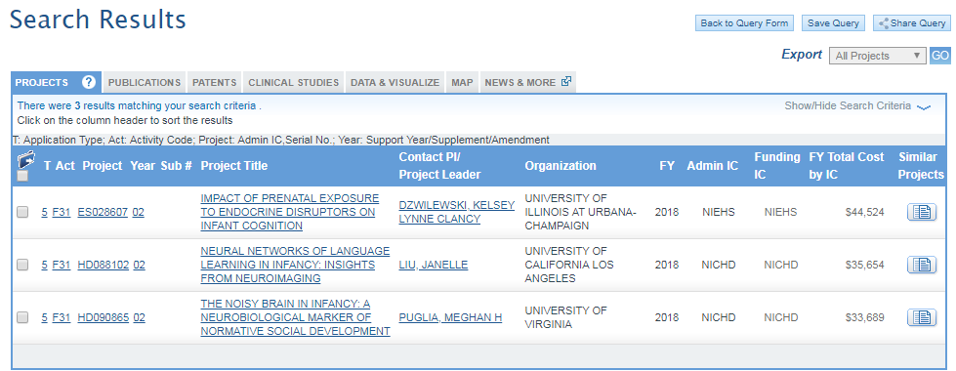
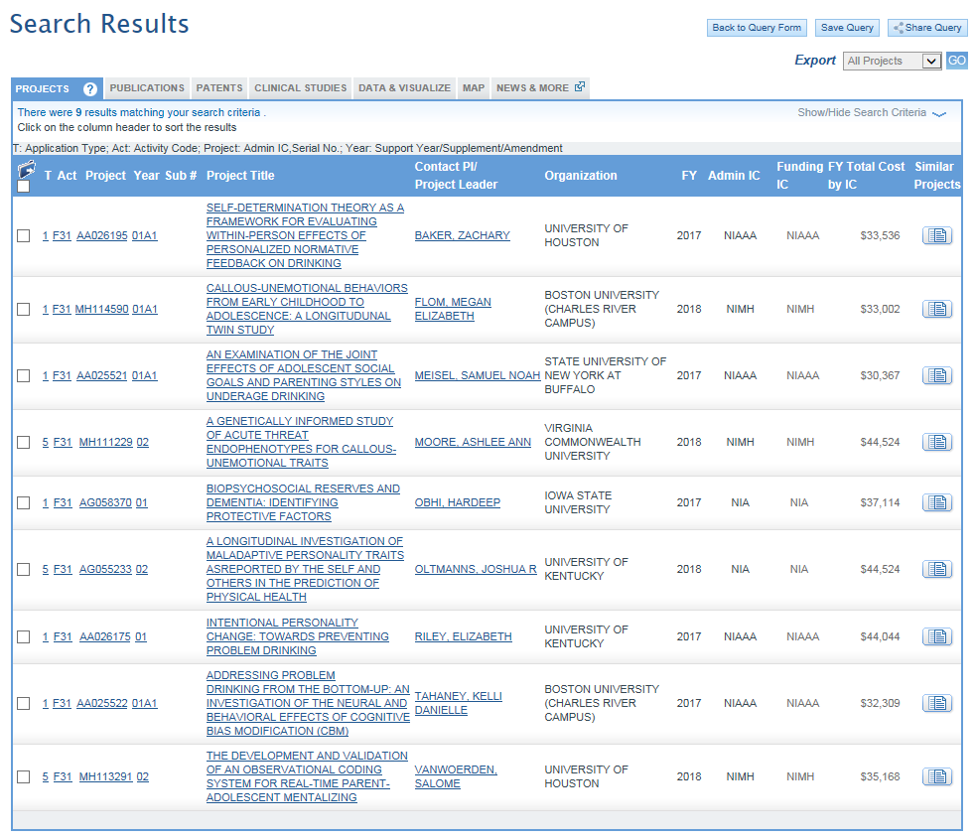
INITIAL PLANNING
Now that you are familiar with the general content and scope of F31s, be sure that your submission aligns with your broader graduate training trajectory. NIH accepts F31 applications during three cycles with specific due dates, start dates, and review dates. Your application is scored during the scientific merit review phase. You may receive your score within 24-48 hours of your review date. However, your “pink sheets” (detailed feedback) are sometimes not available for a few weeks. Thus, it may not be possible to immediately resubmit in the following cycle. For this reason, it is best to start thinking about your goals for a F31 early in your training, and to be ready to submit sooner versus later.
 | Cycle I | Cycle II | Cycle III
F31/F32 Due Date | April 8 | August 8 | December 8
Earliest Start Date | September or December | April | July
Scientific Merit Review | June-July | October-November | February-March
Advisory Council Review | August or October | January | May
For example, Jamie is a 2nd year student in a clinical psychology doctoral program that typically includes 5 years of on-site training and 1 additional year of internship. Jamie would like to submit a two or three-year F31 for the December deadline of her 3rd year. Thus, three scenarios are possible for a successfully funded submission:
OPTION 1: JAMIE HITS THE JACKPOT ON HER INITIAL SUBMISSION
3 YEAR DATE
7/1/22
INITIAL SUBMISSION
12/8/18
START WRITING
6/8/18
PEER REVIEW
2/15/19
NIMH
COUNCIL
5/15/19
START DATE
7/1/19
2 YEAR DATE
7/1/21

4th and 5th Years
(2019-21)
3rd Year of Graduate School
(2018-19)

OPTION 2: JAMIE RECEIVED ENCOURAGING REVIEWS IN A TIMELY MANNER
3 YEAR DATE
12/1/22
2 YEAR DATE
12/1/21
PEER REVIEW
7/1/19
RESUB
4/8/19
PEER REVIEW
2/15/19
NIMH COUNCIL
10/1/19
START DATE
12/1/19

6th Year
(2021-22)
4th and 5th Years
(2019-21)
3rd Year of Graduate School (2018-19)

OPTION 3: JAMIE HAD A LOT TO REVISE AND/OR DIDN’T RECEIVE REVIEWS QUICKLY
3 YEAR DATE
4/1/23
2 YEAR DATE
4/1/22
PEER REVIEW
11/1/19
RESUB
8/8/19
PEER REVIEW
2/15/19
NIMH COUNCIL
1/1/20
START DATE
4/1/20

6th Year
(2021-22)
7th Year
(2022-23)
4th and 5th Years
(2019-21)
3rd Year
(2018-19)
LIFE GOALS MAD LIBS
Now that you have are eligible and have a rough timeline, your next step is to determine what you’d like to actually get out of the F31. How is this F31 critical to both accelerating your career trajectory and satisfying NIH’s mission?
The goal of this exercise is to establish a broad plan for “working backwards” from your career goals to localize the areas of expertise that could be developed through a F31 award, as well as link this trajectory for a specific NIH institute’s mission. Try to fill in the following statements:
“If funded, this research and training plan will help me achieve my career goal of
establishing a high-impact research career in [field]
___________________________________________________________
by enabling me to develop unique expertise in [research program you could do for ~10 years]
_________________________________________________________________________________________
Furthermore, the data I collect through my research plan will provide the preliminary publications and pilot data necessary for me to establish myself as an emerging expert in [<5 word version of previous line] _________________________________________________________________________.
This expertise will enable me to address [public health issue]
________________________________________________________________________________________,
which directly relates to [Institute’s] mission to
_______________________________________________________________________________________.”

AVAILABLE RESOURCES
What NIH-funded datasets, public access databases, participant/subject samples, or other resources are available for your research plan? List here any potential resources that may help you address your goals, develop your skills, and develop an independent subline of work. You may use your training funds ($3-$4k) to supplement these resources, however it is unlikely that you will be funded to do a project that solely uses your training allowance. If you are having trouble here, check NIH Reporter for NIH-funded resources at your institution. Ask mentors to help you brainstorm.

MENTORSHIP TEAM
Now, how can you establish this expertise? You will want to refine your “mad lib” in terms of the resources and research mentorship available to you. A major component of the F31 is mentorship. You may need to adjust your madlib to fit your mentorship environment, and/or seek co-mentors and collaborators from outside of your institution who can support your training goals.
Start brainstorming potential mentors, collaborators, and letter-writers here. What areas of expertise can they bring to the table? Do you need to start thinking about connecting with this person, either by bumping into them at an upcoming conference or initiating an email exchange? List more people than you think you will need at this stage, and refine your list as you develop your research goals. Key roles will include:
Primary Mentor: Oversees project, always at your institution, usually primary PhD mentor, almost always currently funded by NIH or has access to funded participant sample
Secondary Mentor: Oversees project, almost always at your institution, plays significant role in training (e.g. complete intensive semester-long training in their lab)
Collaborators: Play circumscribed role in project, such as teaching or mentoring on a specific research or professional area, providing access to necessary resources and/or samples
Letter Writers: Not involved in your project in any way but can speak to your skills or training
Your primary institution should carry the bulk of mentorship and resources necessary for your training plan. However, many grants include collaborators, letter writers, and occasionally co-mentors from other institutions. Brainstorm potential team members here. Try to generate as many ideas as possible; you will widdle down your list later.
PEOPLE AT MY INSTITUTION
Person | Potential Role | Mentorship Expertise | Need Plan for Connection?
PEOPLE AT OTHER INSTITUTIONS
Person | Potential Role | Mentorship Expertise | Need Plan for Connection?

Notably, you will want your final research mentorship team to include individuals with:
- Content expertise for every corner of your research and training plan. You should not be the standalone expert in any part of your program of research. If you already have a lot of expertise in one domain, seek a mentor who can support you to push that domain forward. For example, if you have substantial expertise in sleep measurement in young children, include a mentor who can prep you to learn about sleep measurement in older children, alternate methods for sleep, sleep-related clinical trials, novel ways to model sleep. Your mentors should support your continued development in an area, in addition to supporting novel areas of research.
- Strong track records of NIH funding (not all mentors must demonstrate this quality).
- Access to a safe, failproof dataset for your research project. In almost all cases, you should not be collecting a new dataset from scratch with your F31. Ideally, the dataset/patients you will access have already been “peer reviewed” by NIH (e.g. already funded), and someone on your team should be actively working with those data.
- Seniority. If you are relying entirely on junior investigators (e.g. assistant professors), the reviewers may question your mentor’s ability to independently mentor your award. Some junior folks are absolutely fine (even as a primary mentor), but supplement junior-heavy teams with local senior mentors for additional support.
- Actual mentoring skills. Do not only choose senior folks with a lot on their plate because they seem most “prestigious.” Ensure your mentors are actually willing to support your training.

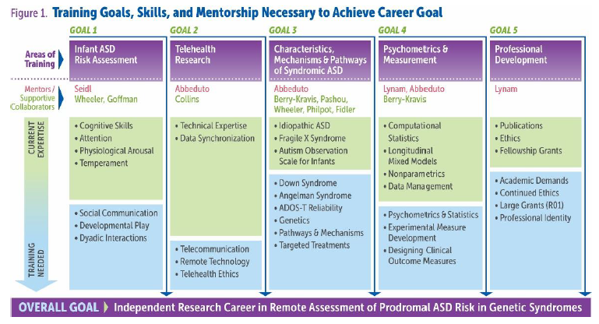
ESTABLISHING TRAINING GOALS
Now comes the most important part: starting to assemble your training goals. Think back to your research trajectory that you outlined in “madlibs.” What training opportunities would help you reach those goals? How far are you on your path to independence? What skills do you have versus need?
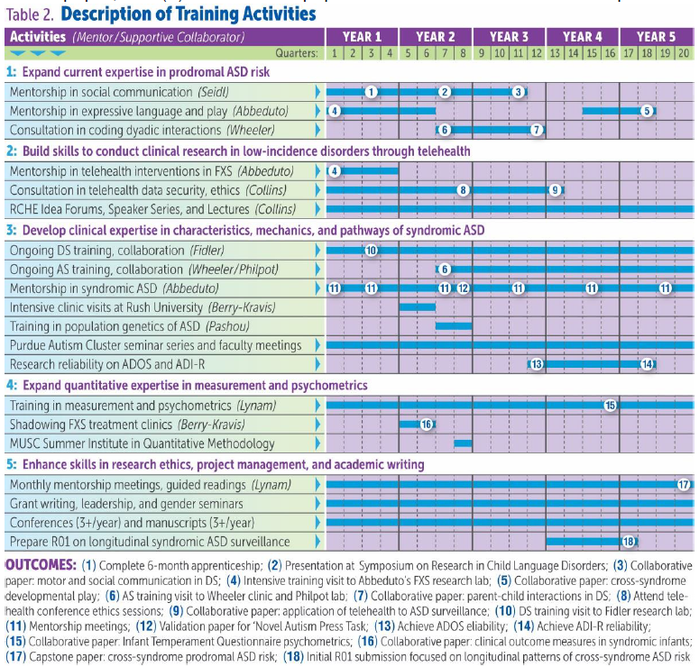
Figure 1 details Dr. Tonnsen’s K23 training plan. This table represents a five year award that is much larger in scope than a F31, however the general structure of a training plan is the same. Most fellowship grants (F31, F32, K08, K23) tend to have 4-5 overarching training goals. One goal is almost always related to professional development, and one goal is almost always related to statistics or measurement. The remaining goals tend to be project specific. Figure 2 describes the training activities that Dr. Tonnsen proposed to meet her career goal. Notice that each activity is nested under a goal and is linked to tangible endproducts, which are included as footnotes.
It is normal to start your F31 with some level of expertise in your training goal areas. For example, you may have a few publications submitted, you may have expertise in basic statistical or clinical techniques, and you may have a year or two of research under your belt related to your clinical population of interest. Think about what skills you need to develop to fill in the gaps as you approach an independent post-graduate career (“Training Needed” section above). How could these skills cluster under specific goals? Where do you need the most support? Who might be able to help you develop these skills?
Your next task is to create your own version of this table. List five potential goals for your grant (3 content, 1 measurement, + professional development). List current areas of strength. Next, list current areas of need. Draw a horizontal line that indicates the relative level of need across goals. Now: who could mentor you to obtain these skills? Start listing your mentors and collaborators, using the list you brainstormed before.
TRAINING GOALS

 | Goal 1 | Goal 2 | Goal 3 | Goal 4 | Goal 5
 | Project-Specific | Project-Specific | Project-Specific | Statistics and/or Measurement | Professional Development
Goal:

Mentors:

Collaborators:

Current Expertise
Training Needed

DESCRIPTION OF TRAINING ACTIVITIES WORKSHEET
Training Activities: Goal 1 | Year 1 |  |  |  | Year 2 |  |  |  | Year 3
 | 1 | 2 | 3 | 4 | 5 | 6 | 7 | 8 | 9 | 10 | 11 | 12
Potential Endproducts:

Training Activities: Goal 2 | Year 1 |  |  |  | Year 2 |  |  |  | Year 3
 | 1 | 2 | 3 | 4 | 5 | 6 | 7 | 8 | 9 | 10 | 11 | 12
Potential Endproducts:
Training Activities: Goal 3 | Year 1 |  |  |  | Year 2 |  |  |  | Year 3
 | 1 | 2 | 3 | 4 | 5 | 6 | 7 | 8 | 9 | 10 | 11 | 12

Potential Endproducts:

DESCRIPTION OF TRAINING ACTIVITIES WORKSHEET, continued
Training Activities: Goal 4 | Year 1 |  |  |  | Year 2 |  |  |  | Year 3
 | 1 | 2 | 3 | 4 | 5 | 6 | 7 | 8 | 9 | 10 | 11 | 12
Potential Endproducts:

Training Activities: Goal 5 | Year 1 |  |  |  | Year 2 |  |  |  | Year 3
 | 1 | 2 | 3 | 4 | 5 | 6 | 7 | 8 | 9 | 10 | 11 | 12
Potential Endproducts:

NEXT STEPS
You are now well positioned to start crafting your research and training plans, which will integrate your career goals, training activities, and available institutional resources. Next steps will include:
- Discussing your training goals with your mentorship team
- Writing a detailed, integrated training plan
- Establishing a feasible and impactful research plan
- Writing your application
- Tailoring your writing to peer review
- Soliciting feedback
- Understanding the review process
- Completing your actual project
… stay tuned!

